**WEEK 7 HANDSON -REACT**

**HandsOn 9 :**

**In this hands-on lab, you will learn how to:**

* **Use map() method of ES6**
* **Apply arrow functions of ES6**
* **Implement Destructuring features of ES6**

**CODES AND OUTPUT :**

**Step 1 :**

**Create a React Application named “cricketapp”**

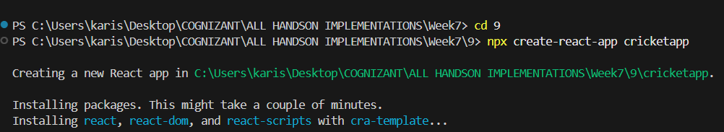

**cd cricketapp**

**npm start**

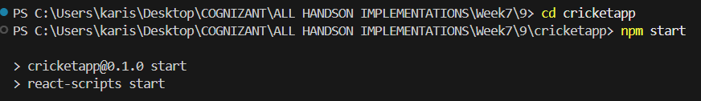

**Step 2 :**

**Create a folder called components.**

**Add the following two components :**

1. **ListofPlayers.js**
2. IndianPlayers.js

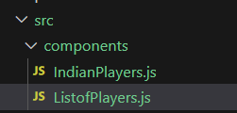

**Step 3 :** ListofPlayers.js:

* Declare an array with 11 players and store details of their names and scores using the map feature of ES6

import React from 'react';

const ListofPlayers = () => {

  const players = [

    { name: "Virat Kohli", score: 85 },

    { name: "Rohit Sharma", score: 92 },

    { name: "KL Rahul", score: 45 },

    { name: "Hardik Pandya", score: 78 },

    { name: "MS Dhoni", score: 67 },

    { name: "Ravindra Jadeja", score: 55 },

    { name: "Jasprit Bumrah", score: 12 },

    { name: "Mohammed Shami", score: 8 },

    { name: "Yuzvendra Chahal", score: 23 },

    { name: "Bhuvneshwar Kumar", score: 35 },

    { name: "Shikhar Dhawan", score: 88 }

  ];

}

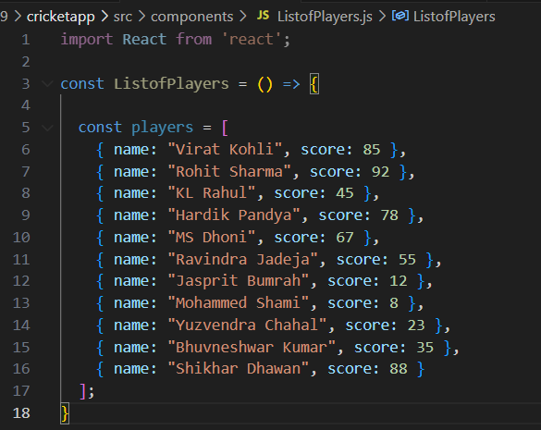

* Filter the players with scores below 70 using arrow functions of ES6.

const players70 = players.filter((item) => item.score < 70);

return (

<div>

<h2>All Players</h2>

{players.map((item) => (

<div key={item.name}>

Mr. {item.name}: <span>item.score: {item.score}</span>

</div>

))}

<h2>Players with Score Below 70</h2>

{players70.map((item) => (

<div key={item.name}>

Mr. {item.name}: <span>item.score: {item.score}</span>

</div>

))}

</div>

);

};

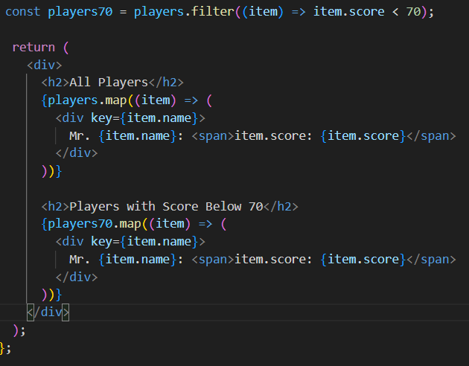

**Step 4:**

IndianPlayers.js

* Display the Odd Team Player and Even Team players using the Destructuring features of ES6

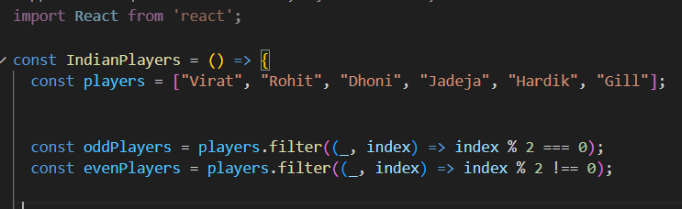

* Declare two arrays T20players and RanjiTrophy players and merge the two arrays and display them using the Merge feature of ES6

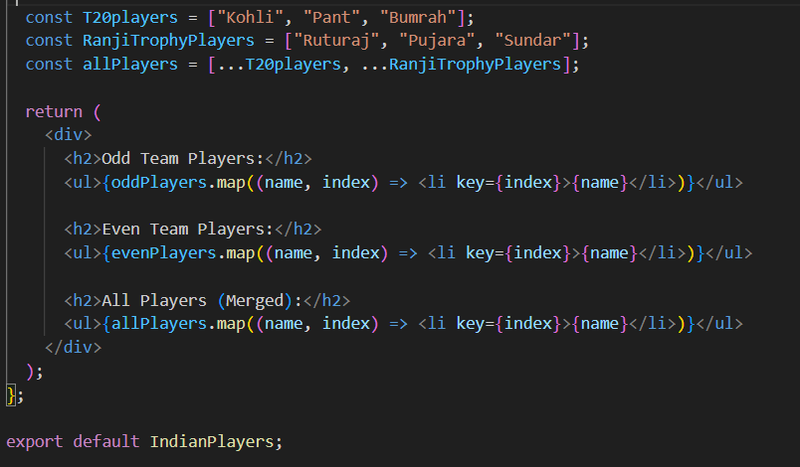

**IndianPlayers.js:**

import React from 'react';

const IndianPlayers = () => {

const players = ["Virat", "Rohit", "Dhoni", "Jadeja", "Hardik", "Gill"];

const oddPlayers = players.filter((_, index) => index % 2 === 0);

const evenPlayers = players.filter((_, index) => index % 2 !== 0);

const T20players = ["Kohli", "Pant", "Bumrah"];

const RanjiTrophyPlayers = ["Ruturaj", "Pujara", "Sundar"];

const allPlayers = [...T20players, ...RanjiTrophyPlayers];

return (

<div>

<h2>Odd Team Players:</h2>

<ul>{oddPlayers.map((name, index) => <li key={index}>{name}</li>)}</ul>

<h2>Even Team Players:</h2>

<ul>{evenPlayers.map((name, index) => <li key={index}>{name}</li>)}</ul>

<h2>All Players (Merged):</h2>

<ul>{allPlayers.map((name, index) => <li key={index}>{name}</li>)}</ul>

</div>

);

};

export default IndianPlayers;

**Step 5 :**

Display these two components in the same home page using a simple if else in the flag variable.

**Output:**

**When Flag=true**

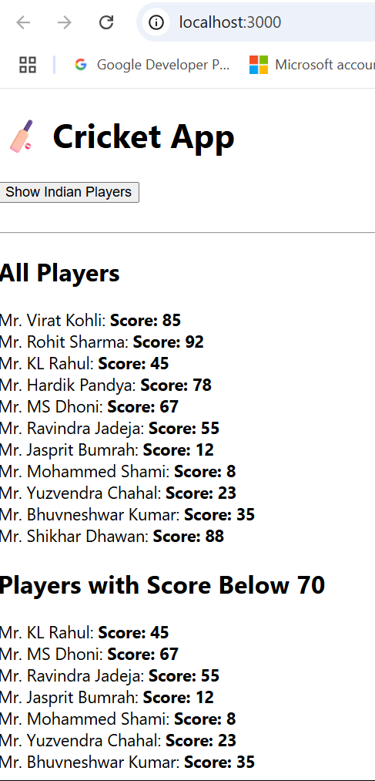

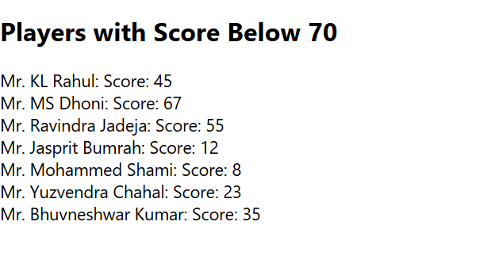

**When flag =false**

